AE 4342 – Lab 10

# Data Storage Requirements

a) 1 pass lasts 6.2*60 = 372s

Total amount of information transferred is 372*1.2 = 446.4Mb

40/700 of all data is health

40/700 * 446.4 = 25.5Mb = 3187500bytes/1024^2 = 3MiB

b) 660/700 * 446.4 =420.9 Mb = 52612500 bytes /1024^2 = 50.2 MiB

c)8 hrs = 28800s

40Bytes of health data is collected every second

660 Bytes of payload data is collected every second

Total amount of data collected over 8hrs = 700*28800 = 20160000 Bytes = 19.2 MiB

40/700 of all data is health

40/700 * 19.2 = 1.1MiB

660/700 is payload 🡪 660/700 * 19.2 = 18.1 MiB

Yes, this will fit in the 64 MiB limit of the flight system

d) 1024*1024*8 = 8388608 bits = 1048576 Bytes per image = 1 MiB

e) Total amount of data to be transferred per pass is 53.2

As such the amount of available space for data transmission is 53.2 – 19.2 = 34 MiB

As each picture is 1 MiB, a total of 34 images can be transmitted in addition to the payload and health data.

# C&DH Research

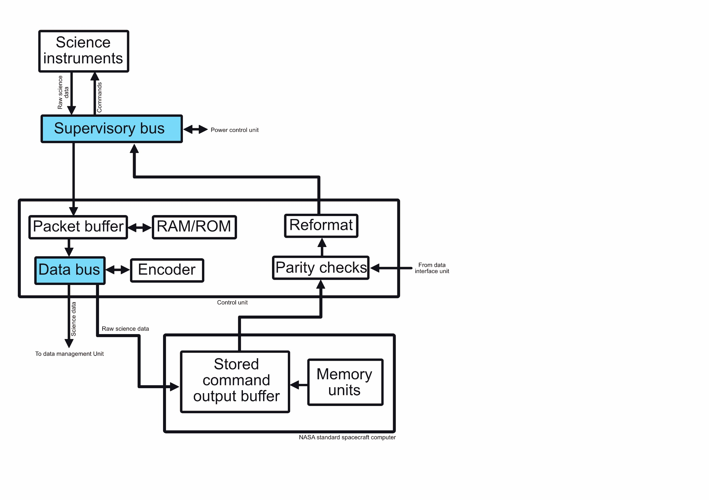

In the above system block diagram we can see that firstly, the science instruments transmit data to a supervisory bus, which is a data bus to the control unit. The raw science data is then transferred to a control unit, whose purpose is to format commands and data as to make them be in the appropriate format for their next destination. This begins by transferring the raw data to be temporarily held in a packet buffer which will transmit it to ROM or RAM storage depending on whether it needs to be stored temporarily (RAM) or for longer periods of time (ROM). In the same time it will be formatted. The data will then be either sent to a data management unit and might be encoded if needed. Some of the data will be sent to the computer, a NSSC-I which will analyze data, while also being able to send specific commands to the instruments. As such, instruments may receive commands from either a data interface unit (which receives commands from the ground), or the onboard computer. These will go through parity checks, which will ensure that the command is correct and has not become erroneous while it was transferred. Finally, the commands are reformatted and sent to science instruments.